How to make the report prompt date be a specific date using SQL | 

Yoel Kortick
Senior Librarian

Question
We have a report in Alma Analytics in the “Fulfillment” subject area in which we analyze the number of loans since a certain a date. The report has a prompt with “Loan Date >= “. The loan date is entered by the user.
We want the date to automatically be 6 months ago, and then the user can change it if desired.
How can we make the loan date automatically be filled in with a value of 6 months ago?

Answer

ONE
Here is the Criteria tab of the report which is made in the “Fulfillment” subject area.
It displays the “Loans (Not in House)” from the “Loan” folder.

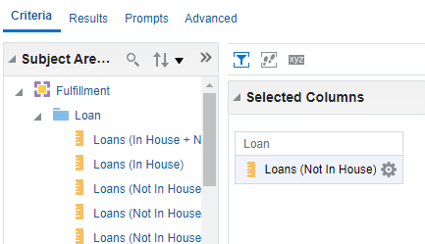

TWO

Here is the Prompts tab. It includes the ‘Date” field from the “Loan Date” folder.

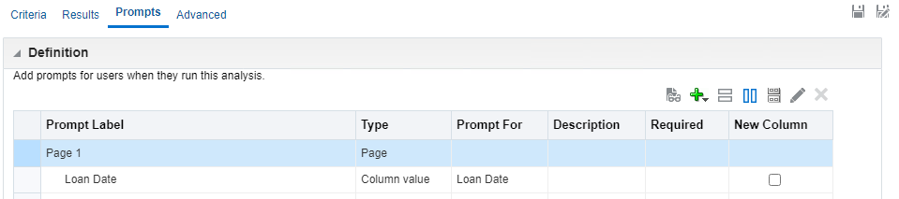

THREE

Currently when we open the report the Loan Date field is empty, and the user can fill in as desired

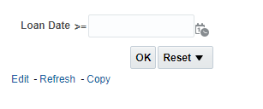

FOUR

Here is how to make the Loan Date field in the prompt automatically be filled in with a date 6 months ago:

- Navigate to the “Prompts” tab
- Double click the “Loan Date” prompt so that it can be edited
- Open the “Options” section by clicking the triangle next to “Options” and then in the “Default Selection” field choose “SQL Results”
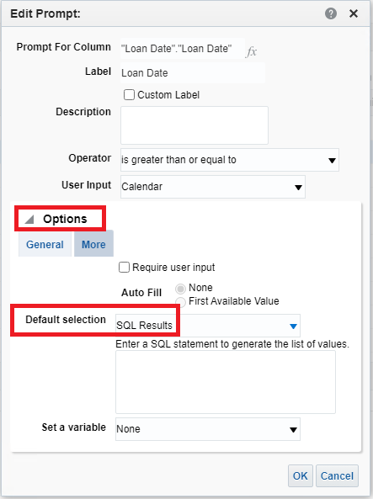
- In the field “Enter a SQL statement to generate the list of values” add the following syntax (change according to whatever date you want:
SELECT TIMESTAMPADD(SQL_TSI_MONTH, -6, CURRENT_DATE)
FROM "Fulfillment"
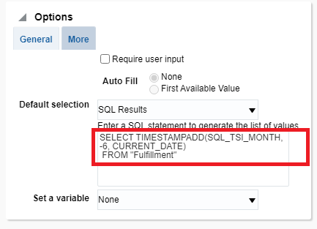
FIVE

Open the report and see that the date is defaulting to 6 months ago (today is July 06. 2021 and the format of the date month/day/year) which is Jan. 06, 2021:
